Created By: VijayKumar Rajendran

Created with: AWS CLI v2

Tested On: Ubuntu 22.04

GitHub URL: <https://github.com/L00171152/GHDemo1VK.git>

# AWS CLI

**a. aws ec2 run-instances --dry-run**

This parameter is used to check whether we have permission/authorization to run the instance without launching the instances.

**b. aws ec2 describe-images**

This parameter is used to provide information about the image/AMI we specify. The images/AMI can be Public, Private or custom image owned by you.

**syntax:**

aws ec2 describe-images <string> <string>

**output:**

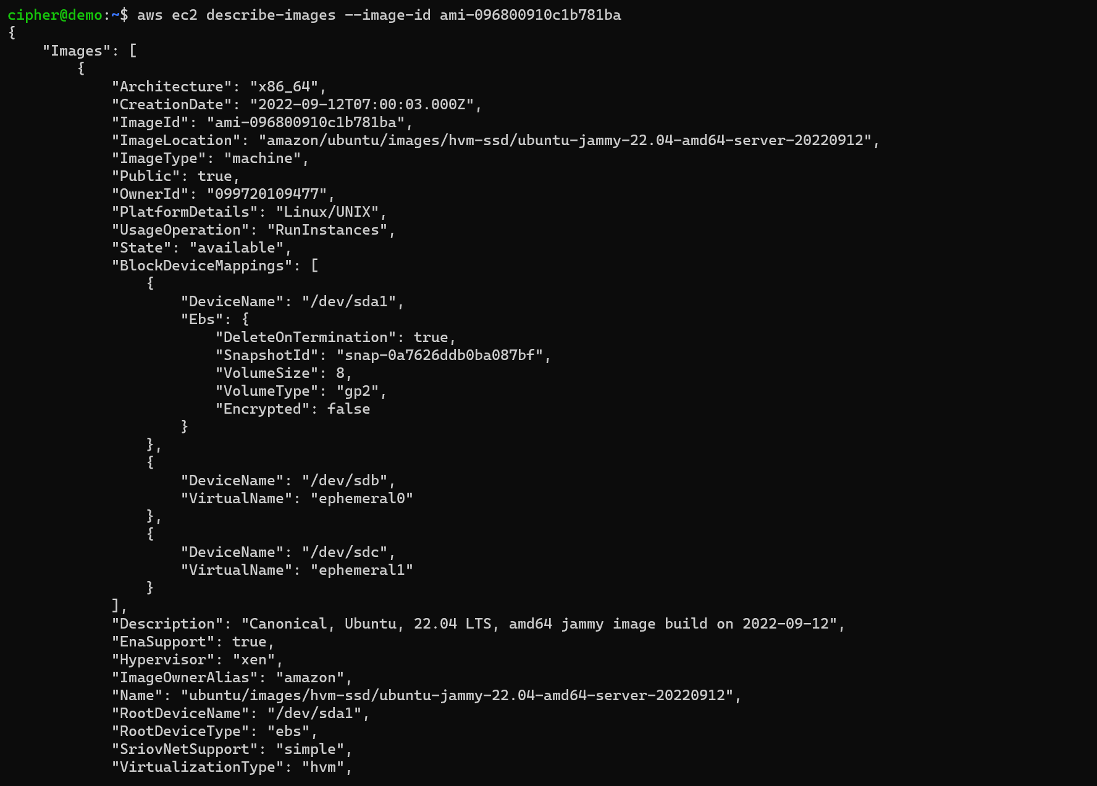

**c. aws ec2 get-console-output**

This command is used to get the console output of the instances. The output shows the boot logs which we can used to investigate if we have any booting issue with the instance

**Example:**

aws ec2 get-console-output --instance-id i-01728ad582d21293b --output text

**Output:**

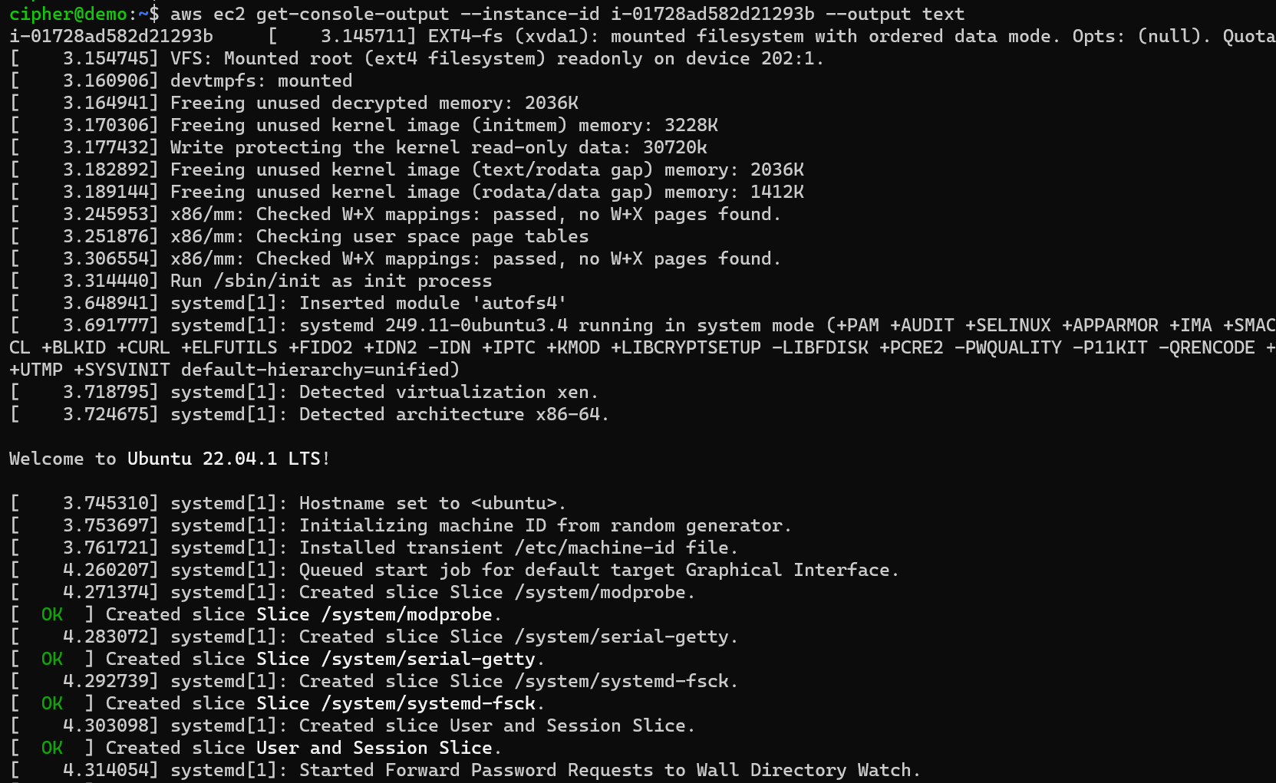

**d. aws ec2 create-snapshot**

This command is used to create snapshot of the instances volume or any EBS volume. The snapshots can be found in EC2 section.

Logically these snapshots are stored in S3 bucket but we cannot visually see them in our s3 account.

**Syntax**:

aws ec2 create-snapshot –volume-id <string>

**Example:**

aws ec2 create-snapshot --volume-id vol-0c0b2f71e54232e54

**Output**:

